1. What is Linux Operating System (OS)? List three pros and cons of it. (CO1)
Ans. Linux is a free and open-source operating system that runs on computers, servers, mobiles, and many other devices.

Pros of Linux Operating system-
- It is free to use
- It is open-source
- It is stable and reliable
- It can run on old or low-power computers.
Cons of Linux Operating system-
- Not many popular apps can run on linux operating system
- Difficulty in connecting hardware devices
- Less support compared to Windows or MacOS

2. Differentiate between Linux, Mac, Android, and Windows OS with at least six unique features. (CO1)
Ans.
Linux | Mac | Android | Windows
It is free to use and can be modified by anyone. | It works only on Apple computers. | As it is open source, it is free and can be customized by phone makers. | It is developed by Microsoft and mostly used in PCs and laptops
We can change almost everything, from appearance to colours. | It has a very user-friendly interface which is smooth, attractive and easy to navigate. | It is mainly for mobile devices and used in smartphones, tablets. | It has an easy to use interface suitable for beginners.
It has very few viruses compared to other operating systems. | It has strong protection against malware and system attacks. | It is secure but depends on phone brand and user settings. | It is more prone to viruses and malware compared to others.
It can run smoothly even on old or low-power computers. | It works very efficiently with Apple hardware. | It runs smoothly on most modern mobile devices. | It works on a wide range of computers and tablets.
It is popular for programming, servers and Cybersecurity. | It comes with pre-installed softwares like Safari. | It comes with Google apps like Play Store, Gmail and YouTube. | It is widely used in offices, schools and for gaming.
Examples- Ubuntu, Kali,etc. | It works seamlessly with iPhone, iPad. | Examples- Android 13, Android 14, etc. | Example- Windows 10, Windows 11, etc.
3. Why is Linux preferred for Mainframe Servers for legacy application? Give three out-of-the-box technical reasons. (CO1)
Ans. Linux is preferred for Mainframe Servers for legacy applications because it is stable, secure and flexible which makes it easy for running old legacy applications that need reliability and long term support.

Three out-of-the-box technical reasons are
- Support for Virtualization- Linux can run many virtual machines on a single mainframe. This allows old legacy applications to run in separate environments safely, without interfering with each other.
- Open-Source Flexibility- Because Linux is open source, developers can modify the system to connect old legacy software with new technologies (like cloud or databases) without replacing the entire setup.
- Efficient Resource Management- Linux uses CPU, memory, and storage very efficiently, which helps mainframes handle heavy workloads and large transactions faster with less power and cost.

4. Explain the structure of the Linux File System with a proper diagram. Note: you can use the tree command to find it out. (CO2)
Ans. The Linux file system is arranged in a hierarchical tree structure that starts from the root directory ( / ), which is the base of the entire system. All files, folders, and devices are organized under this root. Important directories include /bin for basic user commands, /boot for startup files, /etc for configuration files, /home for user data, /lib for shared libraries, /tmp for temporary files, and /var for log files and system data. This structure helps Linux maintain an organized and efficient system where each directory has a specific purpose. The hierarchy can be viewed using the tree / command, which displays the directories and their subfolders in a tree format.
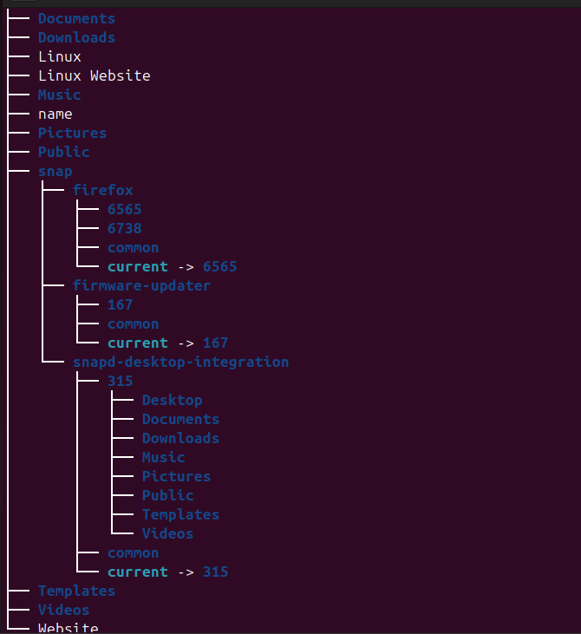

5. If Linux OS is open-source, how do companies like Red Hat still making money from it? Do a market study and answer properly. (CO2)
Ans. Linux OS is open-source but companies like Red Hat still make money from it by following ways
- Support and services- customers that have business pay for installing, maintaining, fixing bugs and handling issues
- Subscriptions- various companies subscribe to enterprise versions that provide stable, tested and certified software releases
- Certificates and training- the organisations provide certification courses through which also they earn money
- Enterprise features- sometimes extra features, performance, stability is provided with the paid versions.

6. Write the command to display today’s date and time (i.e., current System time). (CO1)
Ans. The command to display today’s date and time is
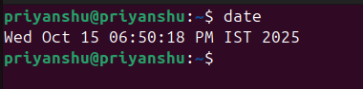

7. Which command is used to check how long the system has been running? (CO1)
Ans. The command used to check how long the system has been running is 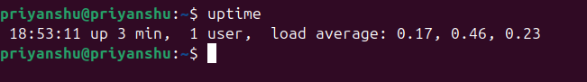

8. What is the difference between shutdown -h now and halt? (CO1)
Ans. The shutdown -h command safely shuts down the system by stopping all processes and then powering off the system

The halt command stops all CPU operations and halts the system instantly, but it may not properly shut down running processes.

9. Compare init 0 and shutdown -h. Which is safer? Why? (CO1)
Ans. The init 0 command changes the system runlevel to 0, which stops all services and then powers off the system. It works properly but may not notify users before shutdown

The shutdown -h command shuts the system down by warning users, stopping all processes safely and then powering off. It is safer because it ensures a clean shutdown and notifies user before shutting down.

10. A system administrator accidentally powers off a Server machine without shutting it down properly. What problems can occur to the said Server? (CO2)
Ans. If a system administrator accidentally powers off a server machine without shutting it down properly, the following problems may occur
- File system corruption- unsaved data or incomplete writes can damage files or the filesystem.
- Data Loss – files being written or updated may get lost or corrupted.
- Hardware Stress – sudden power loss can harm hard drives or SSDs over time.
- Boot Errors – the system may fail to boot properly next time due to corrupted system files.

